Magnitude and Time Shifter Plug-In
This observation transformation plug-in shifts the time and/or magnitude observations in one or more series by the specified amount. It is accessible from the Tool menu. One example use case is: overlaying two or more nova eruptions, e.g. by first creating new series from sets of filtered observations (see Create Series and Previous Filters... View menu items). Another example use case is: shifting the magnitude baseline of observations for an object from different sources.
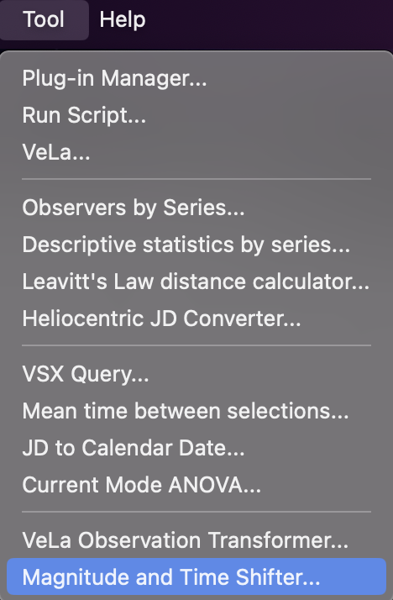

In the following example, purely for demonstration purposes, visual and Johnson V observations for R Lep have been loaded from AID. The plug-in has been chosen from the Tool menu and the Johnson V series selected in the dialog that opens.
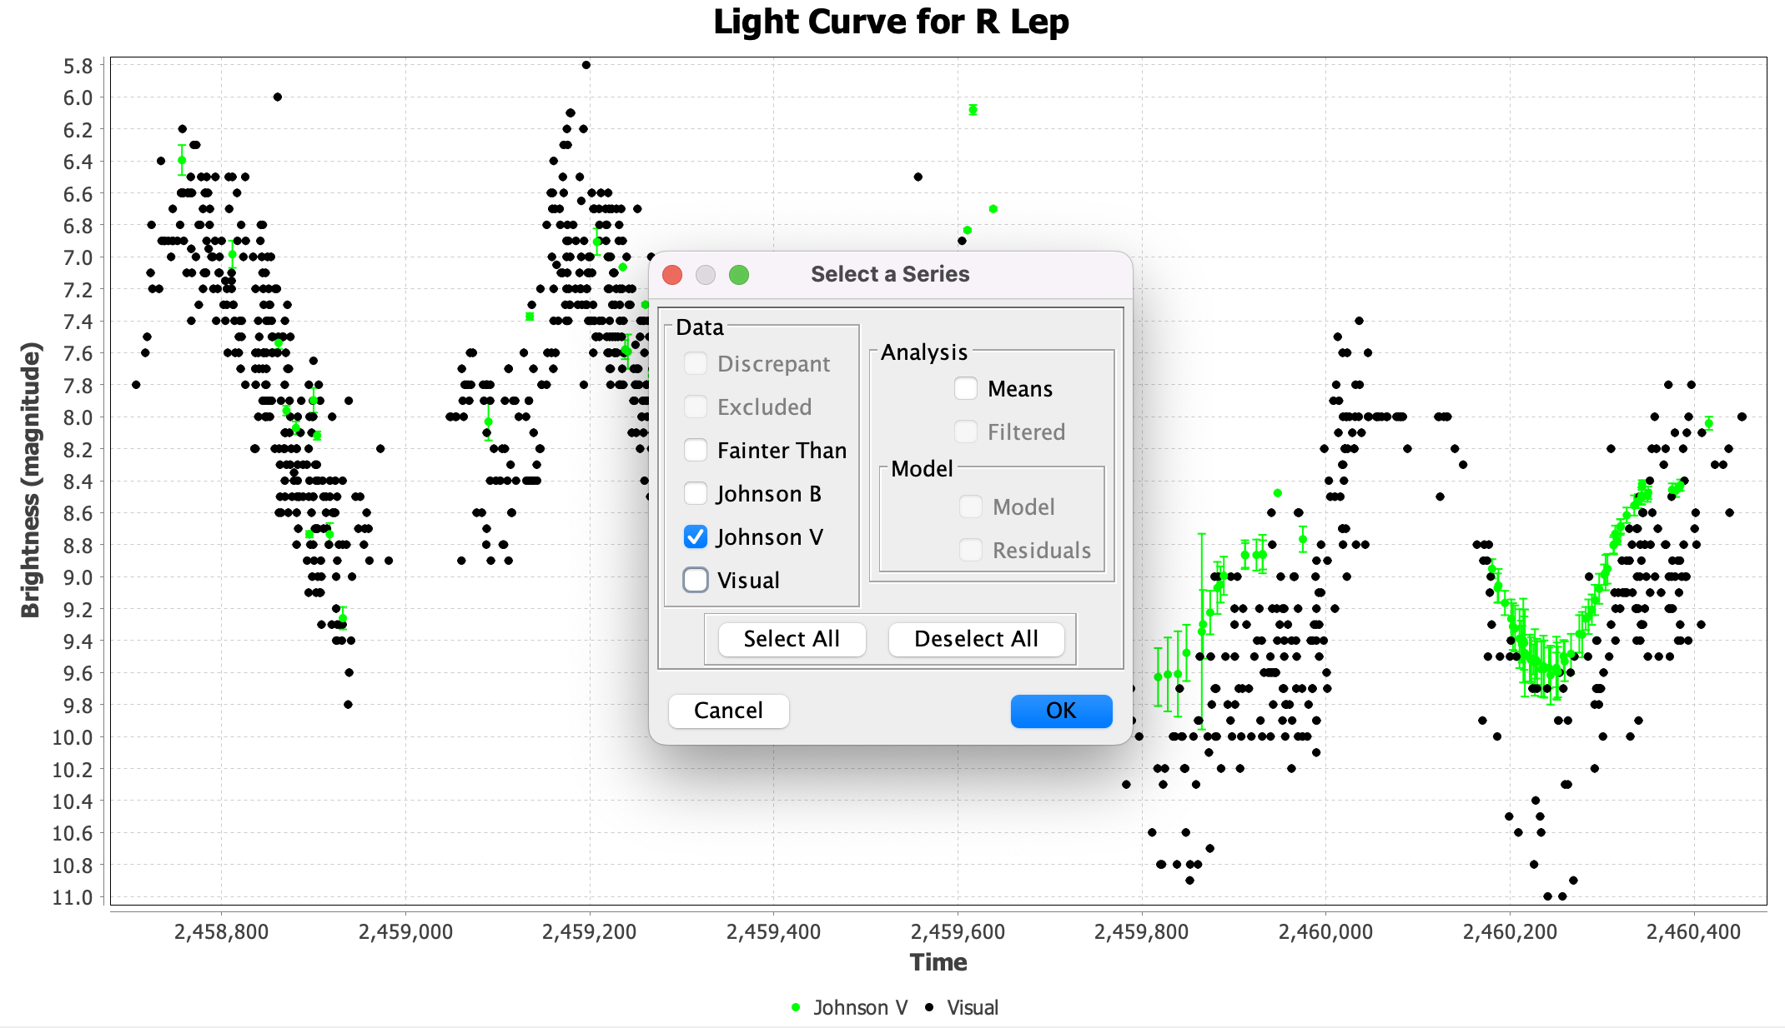

Clicking the OK button yields another dialog, requesting the amounts to shift by in time and magnitude, which can be zero, positive or negative:
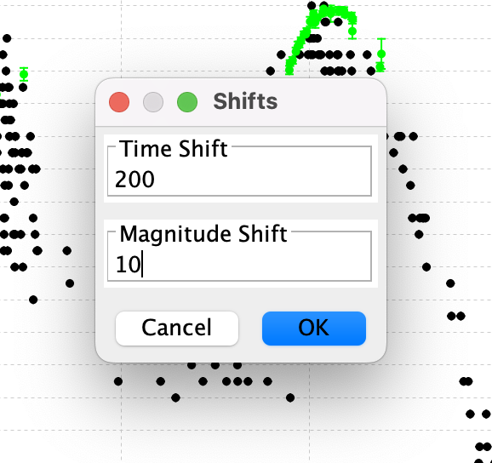

Entering shift values of 200 for time and 10 for magnitude here, and clicking the OK button, adds 200 days to all Johnson V times and 10 to all Johnson V magnitudes.
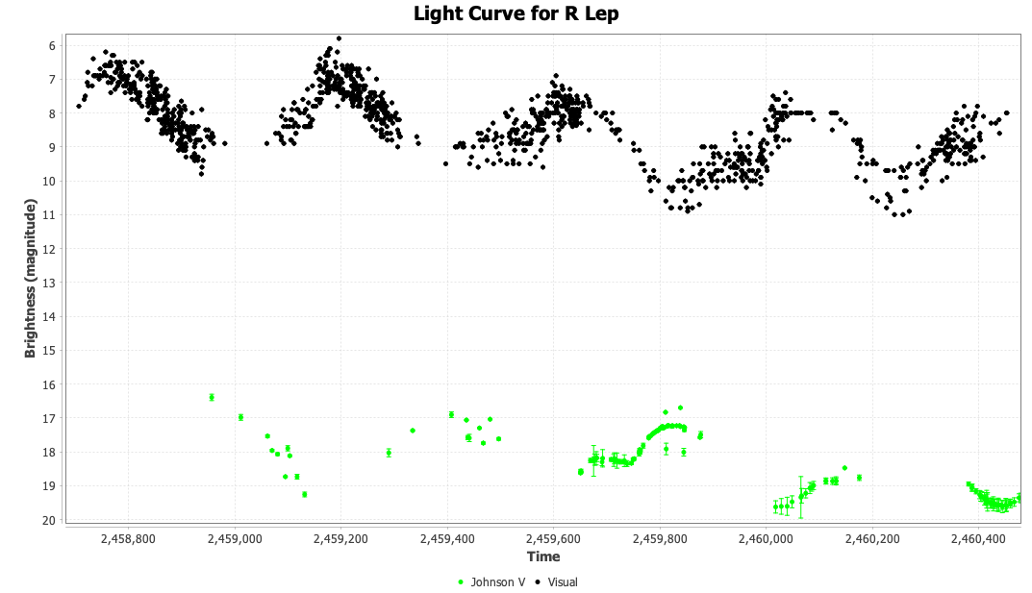

Selecting Undo from the Edit menu undoes this operation:
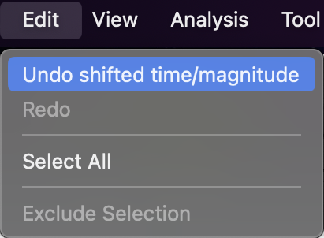
Selecting Redo from the Edit menu applies the original operation again.
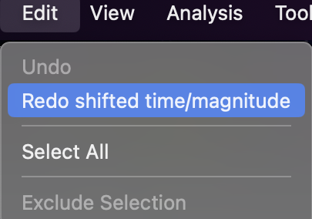

This undo/redo cycle can be repeated.
Using the plug-in again for a new time/magnitude shift operation starts a new undo/redo cycle.

